Name: _____________________________ Date of Birth: ________________ Date:_________________
Section 1: ID Risk Screen
No Travel History Last 7 Days Last 14 Days Last 21 Days Last 2 Months
Recent Travel Location: _________________________________________________________________
Family Member/Household/Contact Travel History
No Travel History Last 7 Days Last 14 Days Last 21 Days Last 2 Months
Recent Travel Location: _________________________________________________________________
*Contact with person with highly contagious disease (Ebola/MERS/2019-nCoV) AND have one or more of the systems below: Yes No
*Travel to a country with wide-spread (Ebola/MERS/2019-nCoV) in the past 21 days AND have one or more of the systems below: Yes No
Ebola Symptoms: Fever, Headache, Weakness, Muscle Pain, Vomiting, diarrhea, Abdominal Pain or Hemorrhage
MERS (Middle East Respiratory Syndrome) Symptoms: Fever, Chills/Rigors, Headache, Sore Throat, Cough, Difficulty Breathing, Nausea, Vomiting, Diarrhea, Abdominal Pain or Muscle Pain
Zika Symptoms: Macular or Papular Rash, Fever, Arthralgia or Conjunctivitis
Some symptoms are not unique for TB. For new or worsening cough, provide patient with a mask.
2019-nCov (2019-nCoV Novel Coronavirus) Symptoms: Fever and symptoms of lower respiratory illness (e.g., cough, difficulty breathing)
Infectious Disease Risk Factors/Symptoms—(Only if YOU or FAMILY MEMBER has traveled)
 | Yes | No
Vomiting
Diarrhea
Abdominal(Stomach Pain)
Weakness/Numbness
Exposure to Disease
Abnormal Breathing
Unexplained bruising
Joint Pain
Abscess
Rash

 | Yes | No
Chills
Fever
Fatigue
Headache
Runny or Stuffy Nose
Sore Throat
Difficulty Breathing
Shortness of Breath
New or Worsening Cough
Wheezing
MDRO History Surveillance
 | Yes | No
History of Clostridium Difficile
History of Extended Spectrum beta-Lactamase
History of MRSA
History of Vancomycin-resistant enterococci
History of Carbapenem-resistant Enterobacteriaceae
Other
Verify droplet, Contact Isolation for Ebola: Yes N/A
*Verify Airborne, Contact Isolation for MERS/2019-CoV: Yes N/A
Does the patient have any of the following conditions that compromise the immune system?
○ None  ○ Acquired immune deficiency syndrome (AIDS)  ○ AIDS related complex (ARC)  ○ Any immunodeficiency syndrome  ○ Chronic Lymphocytic Leukemia (CLL)  ○ Congenital or hereditary immunodeficiency  ○ Human Immunodeficiency Virus (HIV)  ○ Leukemia within 90 days  ○ Lymphocytic Leukemia within 90 days  ○ Marked Neutropenia within 90 days  ○ Myelodysplasia within 90 days | ○ Myelogenic Leukemia within 90 days  ○ Organ Transplant  ○ Pancytopenia within 90 days  ○ Prior hospitalization within 14 days  ○ Radiation therapy within 90 days  ○ Significant neutropenia within 90 days  ○ Systemic chemotherapy within 90 days  ○ Systemic corticosteroid/Prednisone therapy within 90 days  ○ Systemic immunosuppressive therapy within 90 days

Section 2: Summary
Chief Complaint: ____________________________________________________________________
Neck Circumference: ______________inches
Onset of Symptoms: __________________________________________________________________
Additional Information: ________________________________________________________________
Preferred Language: ______________________ Method of Arrival: _____________________________
Arrived With: ___________________________ Consent Signed: _______________________________
Onset of Symptoms: __________________________ Last Menstrual Period: ________________
Vitals:
BP: ________________ BP site: ________________ HR: ___________ HR Site: _______________
Temp: _____________ Site: ______________ RR: _________ SpO2 %: _____________ O2: __________
Measurements:
Height: ____________in/cm Weight: ____________lb/kg Method Weight Obtained: ____________
Head Circumference: _____________________cm Abdominal Circumference: _________________cm Chest Circumference: _____________________ cm

Section 3: Problems and Visit Diagnosis: Any changes from your previous visit?
Diagnosis: Why are you being seen today? _____________________________________________________________________________________
Past Medical History:
Date | Problem

Section 4: Medications/Allergies: Any changes from your previous visit?
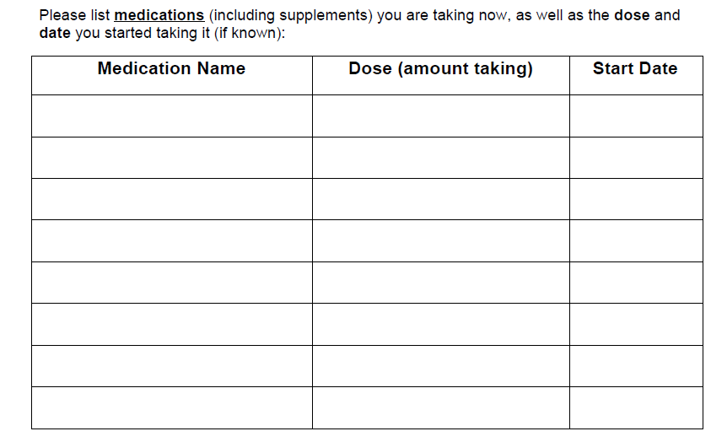
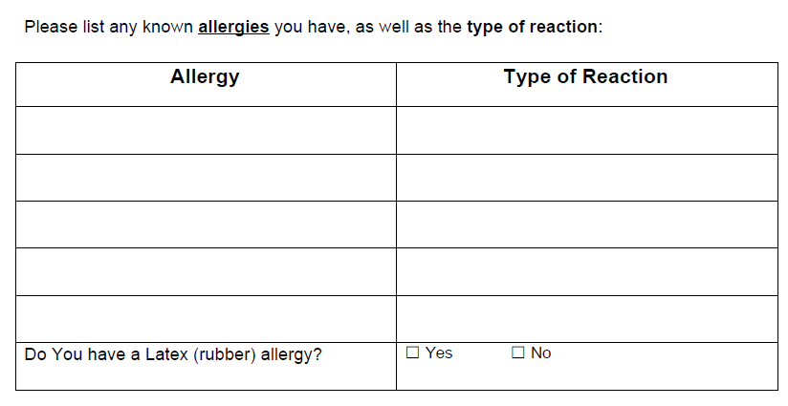

Section 5: Procedures/Surgeries: Any changes from your previous visit?

Anesthesia and Transfusions:
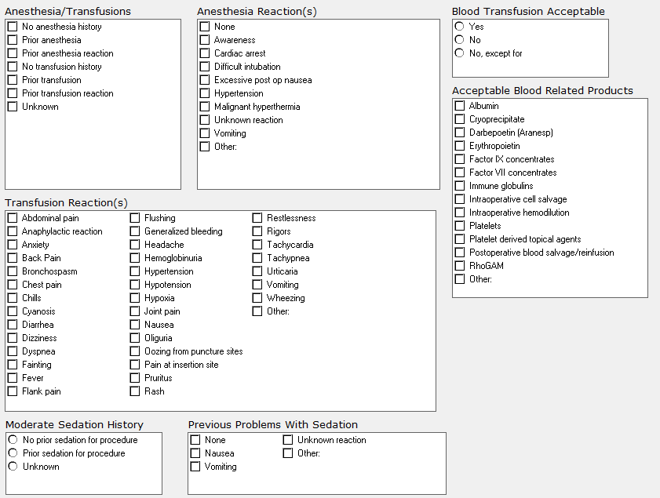

Section 6: Family History: Any changes from your previous visit?

Section 7: Social History
Have you been hospitalized outside the US in past 6 months? Yes No
Patient shows signs/symptoms of neglect? Yes No
History Assessed: Yes No
Have you used Tobacco anytime during the past 30 days? Yes No
Alcohol Use: Current Past Never
Type: Beer Wine Liquor Other:
Frequency: 1-2 x year 1-2 x month 1-2 x week 3-5 x week Daily Several x Day
Tobacco Use:
Current Status unknown Unknown if ever smoked Current every day smoker
Current some day smoker Former smoker Never smoker
Heavy tobacco smoker Light tobacco smoker
Electronic Cigarette Use:
Never Use, within 90 days Former use, greater than 90 days
Refused screening Unknown/Not Obtained Other
Type: ___________________________ Uses/Inhales per day: _____________________________
Substance Use: Current Past Never
Type: __________________________________________________________________________
Caffeine Use: Yes No
Type: ___________________________ Caffeine per day: _____________________________
Marital Status: Married Single Divorced Widowed Other: _________
Number of Children: _____________________________
Living Arrangements:
Alone Family/Significant Other Assisted Living Other: _________
Do you have daily help needed for self-care? Yes No Name of Caregiver:_________
Activities of Daily Living: Any difficulty with? Speech or Communication Memory
Speech or Communication Memory Bathing Household Duties
Physical Activity: Exercise Type: ___________________ Frequency: ________________________
Section 8: Morse Fall Risk
History of Falling Immediate or Within Last 3 Months: Yes No
Presence of Secondary Diagnosis: Yes No
Use of Ambulatory Aid: Furniture Crutches, cane, walker None, bedrest, wheelchair
IV/Heparin Lock: Yes No
Gait/Transferring: Impaired Weak Normal, bedrest, immobile
Mental Status: Forgets Limitations Oriented to own ability
Section 9: Advance Directives
Advance Directives: Yes No
Patient Wishes to Receive Further Information on Advance Directives: Yes No
Section 10: Health Status
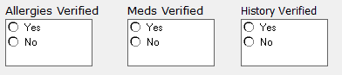
Immunizations Current: Yes No Non Received Unknown Vaccine Recommended
- Other
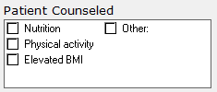
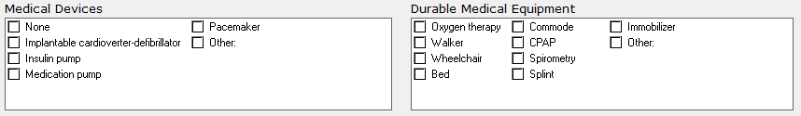

Section 11: Depression Screening
PHQ2-PHQ9 Screening:
Over the past 2 weeks, how often have you been bothered by any of the following problems? | Not At All | Several Days | More than ½ the Days | Nearly Every Day
- Little interest or pleasure in doing things: | 0 | 1 | 2 | 3
- Feeling down, depressed or hopeless: | 0 | 1 | 2 | 3
If you answered 0 to the questions above- stop
- Trouble falling asleep, staying asleep or sleeping too much: | 0 | 1 | 2 | 3
- Feeling tired or having little energy: | 0 | 1 | 2 | 3
- Poor appetite or overeating: | 0 | 1 | 2 | 3
- Feeling bad about yourself: | 0 | 1 | 2 | 3
- Trouble concentrating: | 0 | 1 | 2 | 3
- Moving or speaking so slowly: | 0 | 1 | 2 | 3
- Thoughts that you would be better off dead or of hurting yourself in some way: | 0 | 1 | 2 | 3
- Difficulty at work, home, or getting along with others: | 0 | 1 | 2 | 3
Column Totals:
Add Totals Together:
- If you checked off any problems, how difficult have those problems made it for you to do your work, take care of things at home, or get along with other people?
Not Difficult at all Somewhat Difficult
Very Difficult Extremely Difficult

Adult Questionnaire - Sleep Clinic

Please completely fill in the circles which best describe your current condition. Please answer all questions. Thank you

Pulmonary:
Shortness of breath at rest
Shortness of breath with exercise
Frequent cough
Coughing up blood
Chest pain
Wake up at night short of breath
Recurrent chest infections
Exposure to tuberculosis
Wheezing
Blood clot in legs or lungs

Cardiac:
High blood pressure
Heart attack
Leg swelling
Heart racing or thumping
Rheumatic fever
Needs to sleep on 2 or more pillows
High cholesterol

Constitutional symptoms:
Fever
Night sweats
Chills
Weight loss
Musculoskeletal:
Muscle weakness
Joint pain
Joint swelling
Psychiatric:
Depression
Anxiety
Poor sleep
Snoring
Morning headaches or awakening
Excessive sleep during day
Panic attacks

No
O
O
O
O
O
O
O
O
O
O

O
O
O
O
O
O
O

O
O
O
O
O
O
O

O
O
O
O
O
O O

No
O
O
O
O
O
O
O
O
O

O
O
O
O
O

O
O
O
O
O
O
O
O

O
O
O
O
O
O
O
O
O
O
Yes
O
O
O
O
O
O
O
O
O

O
O
O
O
O

O
O
O
O
O
O
O
O
O
O
O
O
O
O
O
O
O
O

Gastrointestinal:
Trouble swallowing
Choking on food
Heartburn
Abdominal pain
Nausea
Vomiting
Diarrhea
Ulcers
Jaundice

Renal:
Blood in urine
Urinary tract infections
Kidney stones
Frequent urination at night
Painful urination

Neurologic:
Stroke
Migraines
Frequent headaches
Numbness or tingling
Seizure
Dizziness
Imbalance or unsteadiness
Vertigo

Hematology/Oncologic:
Anemia
Cancer
Bleeding tendency
Blood transfusion
ENT:
Blurred vision
Decreased hearing
Frequent sore throat
Sinus infections
Hay fever
Hoarseness

Yes
O
O
O
O
O
O
O
O
O
O

O
O
O
O
O
O
O

O
O
O
O
O
O
O

O
O
O
O
O
O
O

Epworth Sleepiness Scale – Sleep Clinic
How likely are you to doze off or fall asleep in the following situations, in contrast to feeling just tired? This refers to your usual way of life in recent times. Even if you have not done some of these things recently try to work out how they would have affected you. Use the following scale to choose the most appropriate number for each situation:

0 = no chance of dozing
1 = slight chance of dozing
2 = moderate chance of dozing
3 = high chance of dozing

Situation: Chance of dozing (please circle answer)
Sitting and reading | 0 1 2 3
Watching TV | 0 1 2 3
Sitting, inactive in a public place  (theater or meeting) | 0 1 2 3
As a passenger in a car for an hour without a break | 0 1 2 3
Lying down to rest in the afternoon when circumstances permit | 0 1 2 3
Sitting and talking to someone | 0 1 2 3
Sitting quietly after lunch without alcohol | 0 1 2 3
In a car, while stopped for a few minutes in traffic | 0 1 2 3
Total

