Name: _____________________________ Date of Birth: ________________ Date:_________________
Section 1: ID Risk Screen
No Travel History Last 7 Days Last 14 Days Last 21 Days Last 2 Months
Recent Travel Location: _________________________________________________________________
Family Member/Household/Contact Travel History
No Travel History Last 7 Days Last 14 Days Last 21 Days Last 2 Months
Recent Travel Location: _________________________________________________________________
*Contact with person with highly contagious disease (Ebola/MERS/2019-nCoV) AND have one or more of the systems below: Yes No
*Travel to a country with wide-spread (Ebola/MERS/2019-nCoV) in the past 21 days AND have one or more of the systems below: Yes No
Ebola Symptoms: Fever, Headache, Weakness, Muscle Pain, Vomiting, diarrhea, Abdominal Pain or Hemorrhage
MERS (Middle East Respiratory Syndrome) Symptoms: Fever, Chills/Rigors, Headache, Sore Throat, Cough, Difficulty Breathing, Nausea, Vomiting, Diarrhea, Abdominal Pain or Muscle Pain
Zika Symptoms: Macular or Papular Rash, Fever, Arthralgia or Conjunctivitis
Some symptoms are not unique for TB. For new or worsening cough, provide patient with a mask.
2019-nCov (2019-nCoV Novel Coronavirus) Symptoms: Fever and symptoms of lower respiratory illness (e.g., cough, difficulty breathing)
Infectious Disease Risk Factors/Symptoms—(Only if YOU or FAMILY MEMBER has traveled)
 | Yes | No
Vomiting
Diarrhea
Abdominal(Stomach Pain)
Weakness/Numbness
Exposure to Disease
Abnormal Breathing
Unexplained bruising
Joint Pain
Abscess
Rash

 | Yes | No
Chills
Fever
Fatigue
Headache
Runny or Stuffy Nose
Sore Throat
Difficulty Breathing
Shortness of Breath
New or Worsening Cough
Wheezing
MDRO History Surveillance
 | Yes | No
History of Clostridium Difficile
History of Extended Spectrum beta-Lactamase
History of MRSA
History of Vancomycin-resistant enterococci
History of Carbapenem-resistant Enterobacteriaceae
Other
Verify droplet, Contact Isolation for Ebola: Yes N/A
*Verify Airborne, Contact Isolation for MERS/2019-CoV: Yes N/A
Does the patient have any of the following conditions that compromise the immune system?
○ None  ○ Acquired immune deficiency syndrome (AIDS)  ○ AIDS related complex (ARC)  ○ Any immunodeficiency syndrome  ○ Chronic Lymphocytic Leukemia (CLL)  ○ Congenital or hereditary immunodeficiency  ○ Human Immunodeficiency Virus (HIV)  ○ Leukemia within 90 days  ○ Lymphocytic Leukemia within 90 days  ○ Marked Neutropenia within 90 days  ○ Myelodysplasia within 90 days | ○ Myelogenic Leukemia within 90 days  ○ Organ Transplant  ○ Pancytopenia within 90 days  ○ Prior hospitalization within 14 days  ○ Radiation therapy within 90 days  ○ Significant neutropenia within 90 days  ○ Systemic chemotherapy within 90 days  ○ Systemic corticosteroid/Prednisone therapy within 90 days  ○ Systemic immunosuppressive therapy within 90 days

Section 2: Summary
Chief Complaint: ____________________________________________________________________
Neck Circumference: ______________inches
Onset of Symptoms: __________________________________________________________________
Additional Information: ________________________________________________________________
Preferred Language: ______________________ Method of Arrival: _____________________________
Arrived With: ___________________________ Consent Signed: _______________________________
Onset of Symptoms: __________________________ Last Menstrual Period: ________________
Vitals:
BP: ________________ BP site: ________________ HR: ___________ HR Site: _______________
Temp: _____________ Site: ______________ RR: _________ SpO2 %: _____________ O2: __________
Measurements:
Height: ____________in/cm Weight: ____________lb/kg Method Weight Obtained: ____________
Head Circumference: _____________________cm Abdominal Circumference: _________________cm Chest Circumference: _____________________ cm

Section 3: Problems and Visit Diagnosis
Diagnosis: Why are you being seen today? _____________________________________________________________________________________
Past Medical History:
Date | Problem

Section 4: Medications/Allergies
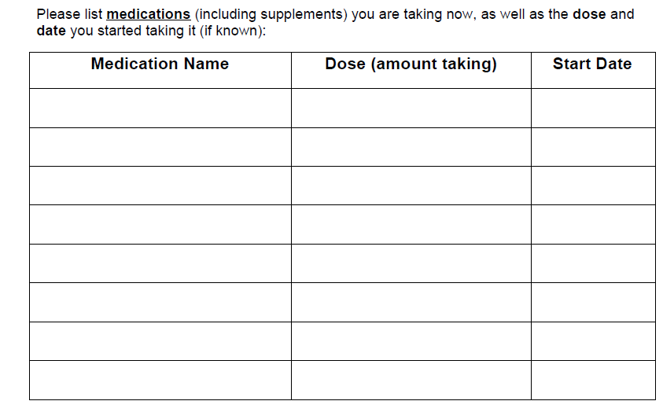
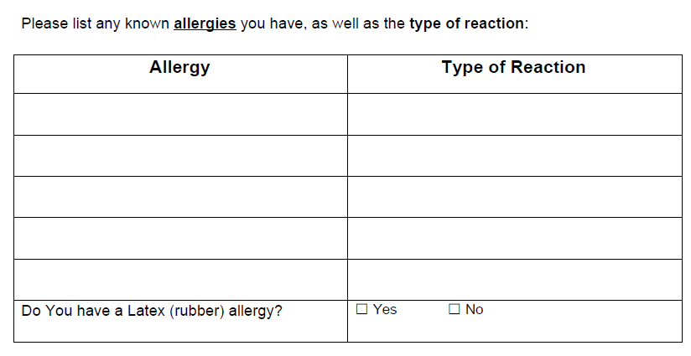

Section 5: Procedures/Surgeries

Anesthesia and Transfusions:
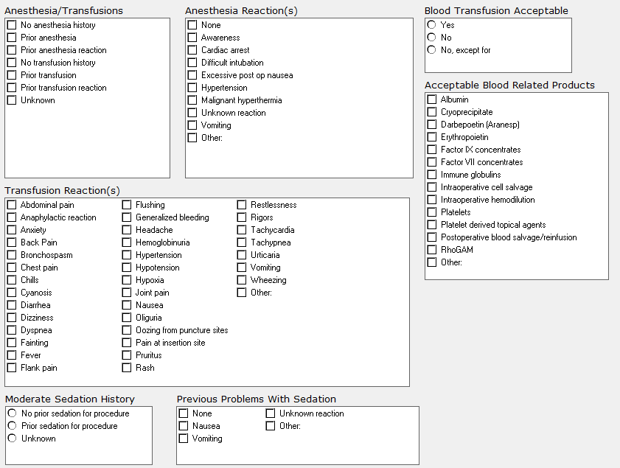

Section 6: Family History
Relationship: | Mother | Father | Sister | Brother | Grandparent
Health Status:
Cardiovascular:
Aneurysm
Heart attack
High blood pressure
Endocrine/Metabolic:
Diabetes Mellitus Type I
Diabetes Mellitus Type II
Thyroid Disease
Eye:
Cataract
Glaucoma
Gastrointestinal:
GERD-Gastro-esophageal reflux disease
Hiatal Hernia
Irritable bowel syndrome
Liver disease
Peptic ulcer disease
Genitourinary:
Enlarged prostate
Incontinence
Kidney disease
Prostate cancer
Hematologic:
Bleeding disorder
Hemophilia
Immunologic:
AIDS
Autoimmune disease
Musculoskeletal:
Acute arthritis
Back Injury
Back Pain
Fibromyalgia
Osteoporosis
Rheumatism
Neurologic:
Alzheimer’s Disease
Migraine
Seizure
Stroke
TIA
Tremor
Oncological: | Mother | Father | Sister | Brother | Grandparent
Bladder Cancer
Bone Tumor
Brain Tumor
Breast Cancer
Colon Cancer
Prostate Cancer
Uterus Cancer
Lung Cancer
Cervix Cancer
Ovary Cancer
Hodgkin’s Disease
Leukemia
Lymphoma
Non-Hodgkin’s Lymphoma
Skin Cancer
Psychiatric:
Addiction
Alcohol Abuse
Anxiety
Bipolar Disorder
Dementia
Depression
Schizophrenia
Suicidal thoughts
Respiratory:
Asthma
COPD
Sleep Apnea
Genetic:
Celiac Disease
Cystic Fibrosis
Down’s Syndrome
Muscular dystrophy
Exposures:
Alcohol User
Substance User
Tobacco User
OTHER:

Section 7: Social History
Have you been hospitalized outside the US in past 6 months? Yes No
Patient shows signs/symptoms of neglect? Yes No
History Assessed: Yes No
Have you used Tobacco anytime during the past 30 days? Yes No
Alcohol Use: Current Past Never
Type: Beer Wine Liquor Other:
Frequency: 1-2 x year 1-2 x month 1-2 x week 3-5 x week Daily Several x Day
Tobacco Use:
Current Status unknown Unknown if ever smoked Current every day smoker
Current some day smoker Former smoker Never smoker
Heavy tobacco smoker Light tobacco smoker
Electronic Cigarette Use:
Never Use, within 90 days Former use, greater than 90 days
Refused screening Unknown/Not Obtained Other
Type: ___________________________ Uses/Inhales per day: _____________________________
Substance Use: Current Past Never
Type: __________________________________________________________________________
Caffeine Use: Yes No
Type: ___________________________ Caffeine per day: _____________________________
Marital Status: Married Single Divorced Widowed Other: _________
Number of Children: _____________________________
Living Arrangements:
Alone Family/Significant Other Assisted Living Other: _________
Do you have daily help needed for self-care? Yes No Name of Caregiver:_________
Activities of Daily Living: Any difficulty with? Speech or Communication Memory
Speech or Communication Memory Bathing Household Duties
Physical Activity: Exercise Type: ___________________ Frequency: ________________________

Section 8: Morse Fall Risk
History of Falling Immediate or Within Last 3 Months: Yes No
Presence of Secondary Diagnosis: Yes No
Use of Ambulatory Aid: Furniture Crutches, cane, walker None, bedrest, wheelchair
IV/Heparin Lock: Yes No
Gait/Transferring: Impaired Weak Normal, bedrest, immobile
Mental Status: Forgets Limitations Oriented to own ability
Section 9: Advance Directives
Advance Directives: Yes No
Patient Wishes to Receive Further Information on Advance Directives: Yes No

Section 10: Health Status
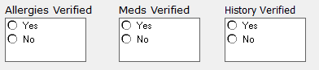
Immunizations Current: Yes No Non Received Unknown Vaccine Recommended
- Other
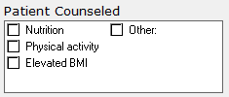
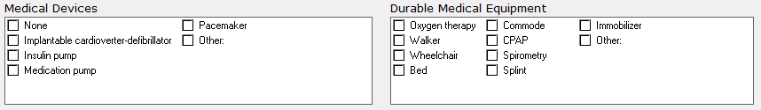

Section 11: Pediatric Depression Screening
Complete if 12 years or younger
PHQ2-PHQ9 Screening:
Over the past 2 weeks, how often have you been bothered by any of the following problems? | Not At All | Several Days | More than ½ the Days | Nearly Every Day
- Little interest or pleasure in doing things: | 0 | 1 | 2 | 3
- Feeling down, depressed or hopeless: | 0 | 1 | 2 | 3
If you answered 0 to the questions above- stop
- Trouble falling asleep, staying asleep or sleeping too much: | 0 | 1 | 2 | 3
- Feeling tired or having little energy: | 0 | 1 | 2 | 3
- Poor appetite or overeating: | 0 | 1 | 2 | 3
- Feeling bad about yourself: | 0 | 1 | 2 | 3
- Trouble concentrating: | 0 | 1 | 2 | 3
- Moving or speaking so slowly: | 0 | 1 | 2 | 3
- Thoughts that you would be better off dead or of hurting yourself in some way: | 0 | 1 | 2 | 3
- Difficulty at work, home, or getting along with others: | 0 | 1 | 2 | 3
Column Totals:
Add Totals Together:
- If you checked off any problems, how difficult have those problems made it for you to do your work, take care of things at home, or get along with other people?
Not Difficult at all Somewhat Difficult
Very Difficult Extremely Difficult

Pediatric Questionnaire - Sleep Clinic

Please completely fill in the circles which best describe your current condition. Please answer all questions. Thank you

Pulmonary:
Shortness of breath at rest
Shortness of breath with exercise
Frequent cough
Coughing up blood
Chest pain
Wake up at night short of breath
Recurrent chest infections
Exposure to tuberculosis
Wheezing
Blood clot in legs or lungs

Cardiac:
High blood pressure
Heart attack
Leg swelling
Heart racing or thumping
Rheumatic fever
Needs to sleep on 2 or more pillows
High cholesterol

Constitutional symptoms:
Fever
Night sweats
Chills
Weight loss
Musculoskeletal:
Muscle weakness
Joint pain
Joint swelling
Psychiatric:
Depression
Anxiety
Poor sleep
Snoring
Morning headaches or awakening
Excessive sleep during day
Panic attacks

No
O
O
O
O
O
O
O
O
O
O

O
O
O
O
O
O
O

O
O
O
O
O
O
O

O
O
O
O
O
O O

No
O
O
O
O
O
O
O
O
O

O
O
O
O
O

O
O
O
O
O
O
O
O

O
O
O
O
O
O
O
O
O
O
Yes
O
O
O
O
O
O
O
O
O

O
O
O
O
O

O
O
O
O
O
O
O
O
O
O
O
O
O
O
O
O
O
O

Gastrointestinal:
Trouble swallowing
Choking on food
Heartburn
Abdominal pain
Nausea
Vomiting
Diarrhea
Ulcers
Jaundice

Renal:
Blood in urine
Urinary tract infections
Kidney stones
Frequent urination at night
Painful urination

Neurologic:
Stroke
Migraines
Frequent headaches
Numbness or tingling
Seizure
Dizziness
Imbalance or unsteadiness
Vertigo

Hematology/Oncologic:
Anemia
Cancer
Bleeding tendency
Blood transfusion
ENT:
Blurred vision
Decreased hearing
Frequent sore throat
Sinus infections
Hay fever
Hoarseness

Yes
O
O
O
O
O
O
O
O
O
O

O
O
O
O
O
O
O

O
O
O
O
O
O
O

O
O
O
O
O
O
O

PEDIATRIC SLEEP HISTORY
This questionnaire will provide the Sleep Disorders Program with a better understanding about your child's case. Please answer all questions to the best of your ability. If any questions are not applicable please leave them blank.
- Child's usual bedtime on weeknights: am/pm
PEDIATRIC SLEEP HISTORY
This questionnaire will provide the Sleep Disorders Program with a better understanding about your child's case. Please answer all questions to the best of your ability. If any questions are not applicable please leave them blank.
- Child's usual bedtime on weeknights: am/pm
- Child's usual wake time on weekdays: am/pm
- Child's usual bedtime on weekends: am/pm
- Child's usual wake time on weekends: am/pm
- On average, how many hours does your child sleep per night? hours
- How long does it usually take your child to fall asleep? minutes
- Under usual circumstances, how often does your child awaken during the night: times per night
- Does your child return to sleep without assistance after waking at night? yes/no
- Does your child awaken too early and have difficulty going back to sleep? yes/no If "yes" estimate how many times per week: times per week
- Does your child fall asleep alone in his/her own bed? yes/no
- Does your child need someone in the room to fall asleep? yes/no
- Does your child need a special object to fall asleep? yes/no
- Does your child go to bed without a struggle? yes/no
- Is your child afraid to sleep in the dark? yes/no
- How long has your child experienced sleep problems? months
- Does your child snore? yes/no If "yes" estimate how long: months
- Does your child grind his/her teeth during sleep? yes/no If "yes" estimate how long: months
- Does your child get up in the night to use the restroom? yes/no
- Does your child stop breathing during sleep? yes/no
- Does your child complain of awakening with a sensation of choking during the night? yes/no
- Does your child breath with his/her mouth open while sleeping? yes/no
- Does your child's arms and legs jerk during sleep? yes/no
- Does your child sleep walk? yes/no
- Does your child talk during sleep? yes/no
- Does your child complain of body pain during sleep? yes/no If "yes" what type? type
- Does your child usually seem rested when he/she wakes up? yes/no
- Does your child usually wake up by him/herself? yes/no
- Does your child have difficulty getting up in the morning? yes/no
- How long does it usually take for your child to become alert in the morning? minutes
- Does your child feel sleepy during the day? yes/no
- How long has daytime sleepiness been a problem for your child? months
- Does your child usually take naps during the day? yes/no
- Does your child usually seem tired? yes/no
- Does sleepiness interfere with your child's normal work/school performance? (Include his/her job and/or home activities) yes/no
- Does sleepiness interfere with your child's normal social activities with family, friends, or other groups? yes/no
- Has your child had accidents or near accidents because of sleepiness? yes/no
- Have you ever been told that a family member has a sleep disorder? yes/no Type of sleep disorder:
- When your child is angry, laughing, or frightened, does he/she complain of feeling weak as though he/she might fall? yes/no
- Does your child remember dreams? yes/no
- Does your child have nightmares? yes/no If "yes" estimate how many per week: per week
- Does your child ever wake up screaming/yelling from a nightmare? yes/no If "yes" estimate how many times per week: per week
- When your child falls asleep or just before he/she wakes up does he/she:
  - Have bizarre dreams? yes/no
  - Feel as if he/she is paralyzed? yes/no
- Does your child have difficulty concentrating? yes/no
- Has your child recently had problems with memory/attention to detail? yes/no
- Have you noticed a difference in your child's personality in the last six months? yes/no
- Does your child feel stressed? yes/no
- Does your child experience anxiety? yes/no
- Does your child ever seem irritable? yes/no
- Has your child recently felt depressed? yes/no
- Does your child have any behavioral problems? yes/no
- Does your child have headaches? yes/no
- Does your child have any allergies? yes/no
- Has your child been diagnosed with ADHD/ADD yes/no
- Does your child have speech problems? yes/no
- Does your child have difficulty swallowing? yes/no
- Has your child had his/her tonsils removed? yes/no
- Does your child have thyroid disease? yes/no
- Does your child have asthma? yes/no
- Does your child have diabetes? yes/no
- Does your child have difficulty breathing? yes/no
- Does your child have any nasal/sinus problems? yes/no
- Has your child ever had surgery on his/her sinuses for a sleep disorder? yes/no
- Does your child have heartburn (acid reflux)? yes/no
- Does your child have any neurological disorders? yes/no
- Does your child have any neuromuscular diseases? yes/no
- Does your child have a history of seizures? yes/no
- Has your child had a traumatic brain injury/concussion? yes/no
- Has your child had a spinal cord/neck injury? yes/no
- Does your child wet the bed? yes/no
- Does your child have any facial abnormalities? yes/no
- Does your child drink caffeinated beverages? yes/no If "yes" estimate how many glasses, cups, or cans per day: per day
- Has your child previously been diagnosed with a sleep disorder? yes/no
- Has your child ever had surgery, taken medications, or received other treatment for sleep-related problems in the past? yes/no
IF "YES" PLEASE ANSWER QUESTIONS 77-80
IF "NO" PLEASE SKIP TO QUESTION 81
- Is your child taking medications for his/her sleep problems? yes/no If "yes" please list
- Does your child ever use an oxygen aid while sleeping? yes/no
- Does your child use nasal CPAP or BIPAP for sleep apnea? yes/no
- If "yes" does he/she feel any different when using CPAP or BIPAP? yes/no If "yes" in what way?
- Do you have any major concerns regarding your child's physical or emotional well-being or overall health due to sleep problems? yes/no
- Does your child enjoy sleep? yes/no
- Does he/she like to sleep late whenever he/she can? yes/no
Please use the following space to comment on anything else you would like us to know about your child's medical or sleep problems.

Parent\Guardian Initials: ________

